CS 7641 Assignment 2

Jeremy Martinez – [jmartinez91@gatech.edu](mailto:jmartinez91@gatech.edu)

**Introduction to the data**

The dataset used in this assignment is a list of restaurant reviews. The attributes are dictated by the description/comment with a binary classification of if the review was positive or negative. The dataset contains 1,000 samples and is split evenly with 500 positive, 500 negative.

I faced new challenges running a dataset like this than when running it in assignment 1. The number of attributes significantly slowed down the training of the neural network. Computation was taking hours and so I was forced to scale back the number of attributes to just the 100 most common words. This did not have a significant impact on the accuracy of my randomized search algorithms, which I will elaborate on.

**Neural Network**

The neural network was trained using three different randomize search algorithms and backpropagation as a basis for comparison to what was used in assignment 1. The three search algorithms used include Random Hill Climbing (RHC), Simulated Annealing (SA), and Genetic Algorithms (GA). The input layer was set to 100. Only one hidden layer was used with a dimension of 40 and an output layer of 1. Each algorithm was run. With 4,000 iterations at which point the algorithm approached convergence. Metrics for each algorithm can be seen in Table 1. Assume 4,000 iterations as a parameter for RHC, SA, and GA. Parameters for GA are in the order of [population, number to mate each iteration, number to mutate each iteration]. Parameters for SA are in the order of [starting temperature, cooling rate].

|  |  |  |  |  |
| --- | --- | --- | --- | --- |
| Algorithm | Parameters | Train Accuracy | Test Accuracy | Time (s) |
| Back Propogation |  | 91.75% | 67.5 | 155 |
| RHC |  | 71.25% | 65% | 64 |
| SA | [1e10, .1] | 75.75% | 65% | 36 |
| SA | [1e10, .3] | 77.5% | 71% | 37 |
| SA | [1e10, .5] | 80.5% | 69% | 64 |
| SA | [1e10, .7] | 74.5% | 66% | 65 |
| SA | [1e10, .9] | 74.5% | 67.5% | 61 |
| SA | [1e6, .1] | 78% | 71.5% | 43 |
| SA | [1e6, .3] | 76.25 | 66.5 | 42 |
| SA | [1e6, .5] | 77.3% | 69.5% | 42 |
| SA | [1e6, .7] | 75.875% | 72.5% | 42 |
| SA | [1e6, .9] | 77.5% | 70.5% | 38 |
| GA | [45, 10, 10] | 57% | 56.5% | 702 |
| GA | [45, 10, 20] | 57.125% | 55% | 868 |
| GA | [45, 20, 10] | 57.875% | 57% | 929 |
| GA | [45, 20, 20] | 60% | 55.5% | 1069 |
| GA | [55, 10, 10] | 53.625% | 44.5% | 612 |
| GA | [55, 10, 20] | 59.375% | 61.5% | 781 |
| GA | [55, 20, 10] | 57.5% | 54.5% | 846 |
| GA | [55, 20, 20] | 60.25% | 56% | 1025 |

Training times across GA took significantly longer than SA, RHC, and Back Propagation for little to no gain. When comparing the performance of each of these algorithms it is important to consider the test accuracy overall, as well as in the context of it’s training accuracy. The contextual analysis demonstrate an algorithms ability to accurately generalize within it’s own implementation. If an algorithm is much less susceptible to overfitting, then further optimizing this algorithm may be more valuable than tweaking an algorithm that is more likely to overfit.

**Back Propagation (control)**

We use back propagation as a control variable to compare against our solution in Assignment 1. Since our analysis from Assignment 1 was on back propagation we won’t delve too deep into this. It is worth noting the discrepancy in training accuracy vs test accuracy. This suggests (overwhelmingly so) overfitting. Despite the rather high accuracy percentage of 91.75% on our training data, back propagation does not generalize well. 67.5% is low in comparison to 91.75% and it is not even the highest test accuracy we found. However, it does still outperform RHC.  
  
**Random Hill Climbing**

Random Hill Climbing is an algorithm that uses a concept of selecting a node at random, then checking a number of neighbors, selecting the highest out of all neighbors, and then repeating the steps until it has found a maxima. This algorithm is easily tricked into local optima since it does not consider anything outside the value of it’s neighbors. To avoid this, the algorithm is restarted several times at random locations. The idea of this is to cover the space.   
  
This algorithm is an issue for my particular dataset since all of the features are binary. Comparing neighbors on a single feature is comparing 1’s and 0’s. This algorithm is more applicable to quantitative features that compare well. Binary comparisons are either true or false and so there isn’t much of a “hill” to climb, so to speak. When comparing binary features in a hill climbing sense, we don’t have continuous data that has the potential to (comparatively speaking) spike in value causing dramatic hills in our data. So binary data is relatively normalized across all our samples. When we visualize this (though hard to do so in 100 dimensions) we can think of the data never having dramatic optima, but instead several “valleys” and “peaks.” This will cause an algorithm like RHC, one that quantitatively compares features to each other, as more of an arbitrary comparison in respect to a binary feature set. This is an important quality to understand moving forward with SA and GA.

RHC trained an accuracy of 71.25% and had a validation accuracy of 65%. Both of these values are lower than the back propagation. We mostly care about the validation accuracy as this is the best indicator of the ability to generalize, though BP still outperformed it. We can analyze this validation accuracy in the context of our train accuracy and then it seems to be less susceptible to overfitting than BP. This metric can be useful to consider and we will revisit this in our over analysis. Accuracy and error curves for RHC can be found in Figures 1 and 2, respectively.

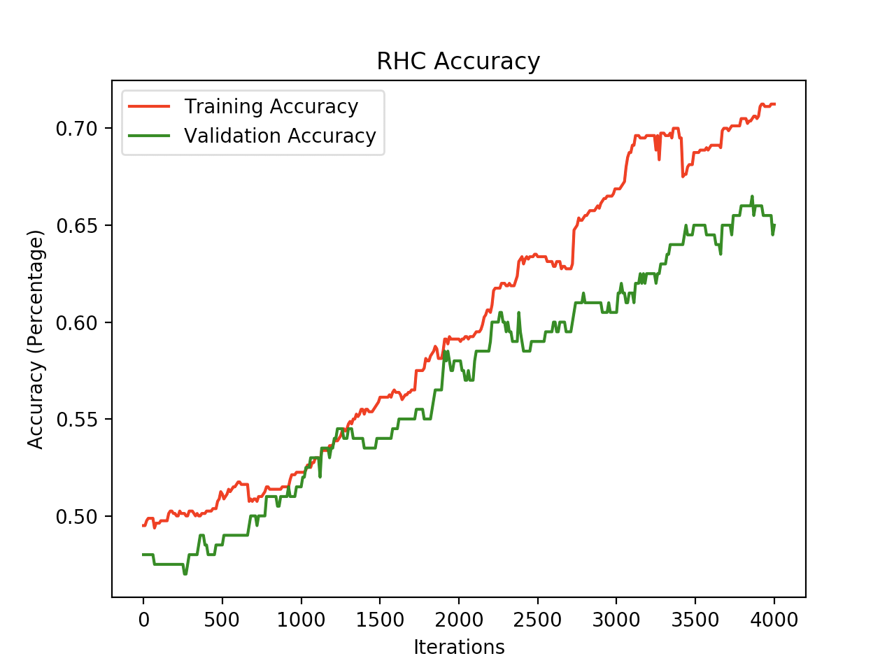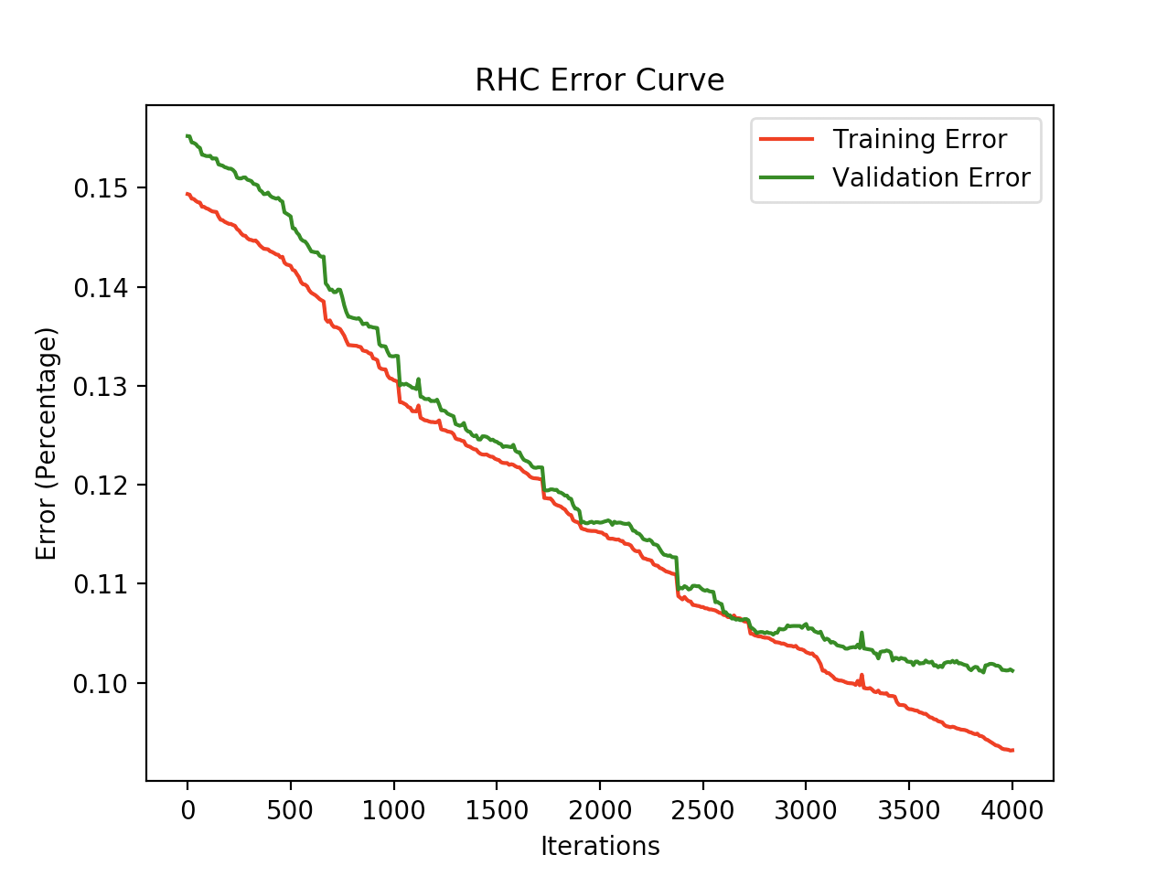  
  
**Simulated Annealing**

Simulated annealing is an algorithm similar to RHC in the sense that is explores it’s neighbors for optima. However, unlike with RHC that selects the highest neighbor no matter what, SA has a probability of selecting a neighbor that is not necessarily the highest. In regard to terminology here, we refer to selecting the highest neighbor as exploiting. Since it is exploiting the neighbor with the highest value in these comparisons, the naming convention makes sense. On the contrary, the idea of choosing a lesser neighbor in hopes of finding a better optimum is a term we refer to as exploring.

The probability of whether the algorithm will exploit or explore is based on an initial rate we pass the algorithm, referred to as the temperature. This probability over the life of the iteration decreases. As the temperature decreases (referred to as the cooling rate), the algorithm approaches the strategy of plain RHC. The motivation behind exploiting rather than exploring is the belief that always exploiting may elude to the algorithm believing it’s data too much (overfitting).

Exploiting resembling overfitting is interesting in the context of this specific dataset. Remember the analysis of our data we covered in RHC, “binary data is relatively normalized across all our samples.” Our data will not contain dramatic optima, so exploring a new neighbor (rather than exploiting) could potentially place us in far away from any optima we were potentially approaching.

For SA we set tried initial temperatures of 1E10 and 1E6. For each of these starting temperatures, we tested cooling rates of 0.1, 0.3, 0.5, 0.7, and 0.9. It’s tough to nail down with absolute certainty what the optimal tuning of these parameters would be in a general case. Our best tuned parameters were [1E6, 0.1] while our second best could arguably be [1E6, 0.5], [1E6, 0.7], or even [1E10, 0.3] depending on how literally you want to scrutinize these metrics. Here we are defining best as the overall highest validation accuracy, meaning the algorithms ability to generalize well. Comparison of these validation accuracies can be seen in Figure 3.

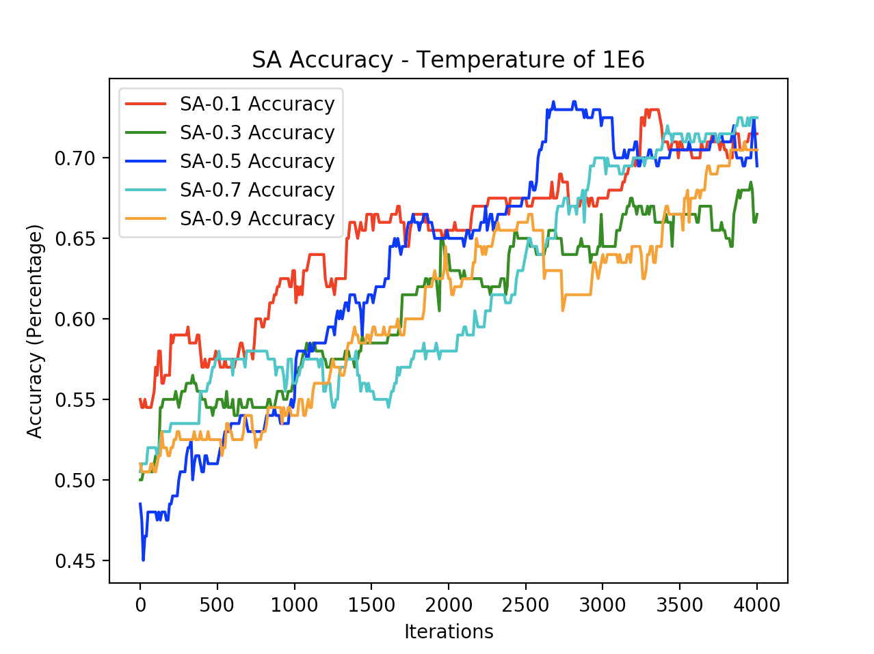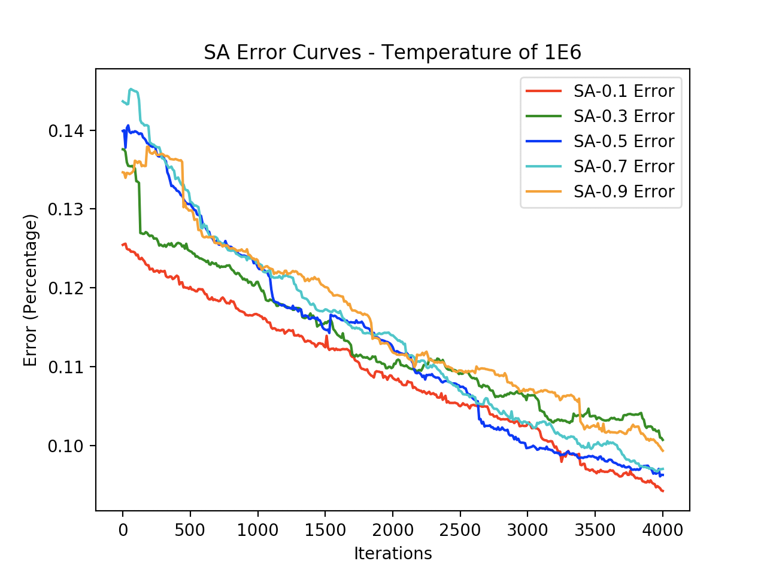

The tuning of these operators in this case is something that should not be taken as a general rule of thumb. Just because [1E6, 0.5] did best here (generalized the best) does not necessarily mean we could use these parameters as our optimal tuned parameters for another set. The question of which parameter set is best implies the answer “it depends.” Though I do believe our initial cooling rate of 1E6 collectively generalized better than 1E10. In deciding [1E6, 0.1] parameter set was the best was due to the fact that it’s validation set peaked (at the highest) of 73% near 3,330 iterations (though it ended 71.5%). It also had the lowest error on the validation set of 9.4% (see figure 4).

Our SA algorithm did the best job of not overfitting as well. This observation is almost more valuable than anything in my opinion. On average, in respect to the training score, SA always did best in fitting the data accurately in respect to the validation set. This means that if we could continue to tweak these parameters we could (possibly) expect that as our training accuracy continues to climb we will see that reflected in our validation (generalized) accuracy. It is also noteworthy to mention that out of all four search algorithms, SA had the lowest error curve.

Now that we have decided SA with parameters [1E6, 0.1] is most optimal for this specific dataset, we are free to explore take this (and maybe the next few parameter sets) and explore different preprocessed sets of the data. We can add layers, consider different feature selection/feature transformation, consider more words (more features). Since these algorithms take so long to compute, we want to explore these search algorithm and parameter sets first. Once we select a subset of what is most optimal to explore, we can continue to try to get our training/validation error down and accuracy up.

**Genetic Algorithm**

Genetic algorithms take a different approach than RHC and SA. In genetic algorithms, we throw away the notion of looking at neighbors and gradually moving in one way or the other toward finding optima. Instead, we take sets of features and tests their performance. Then we take the most N performant of these selections and mutate them on an M number of bits to (hopefully) generate more performant “offspring” of our original hypotheses.

We can think of think of our mutations as neighbors of our original selection. Let’s say, for example, our initial selection is 01101001 where each bit represents a specific word; 0 means this word is not found in the review and 1 means the opposite. In order to take mutations, we will find bit strings that are most performant and mutate an M number of bits to find possibly even more performant bit strings. We will repeat this process over a number of generations (iterations) much like the other algorithms.

GA also introduces a notion of cross over, which will allow us to take the combination of two selections (bit strings) and take a combination of the two. This will allow us to jump across the data set and find more optimal combinations of hypotheses. While one could few the mutation similar to RHC (especially when we only mutate on bit), however, cross over is more sporadic and allows for a more unique traversal of the dataset.

GA was extremely slow in this particular dataset. It was necessary to thread this algorithm just so that the permutations of parameters could all be explored in a timely fashion. For GA we used parameters ranging from a population of [45, 55], a mating rate of [10, 20], and a mutation rate of [10, 20]. These parameters were fairly close to one another and considering the long computation time, it did not seem informationally significant to explore further parameter tuning.  
  
When considering these parameters, a population of 55 had higher accuracy and lower error across the board for the validation set, indicating better generalization. The accuracy curve as well as the error curve for the population of 55 across the rest of the parameters can be seen in Figures 5 and 6, respectively. When analyzing all of these parameters, having a mating rate of 10 and mutation rate of 20 appears to be the best. This conclusion is drawn from the fact that it has the lowest validation error and highest validation accuracy, eluding to best generalization. In the learning curve of the parameters [55, 10, 20] we find that the training converges to (nearly) the same error as the test 12.1% and 12.3%, respectively. This indicates that the GA algorithm is not overfitting.

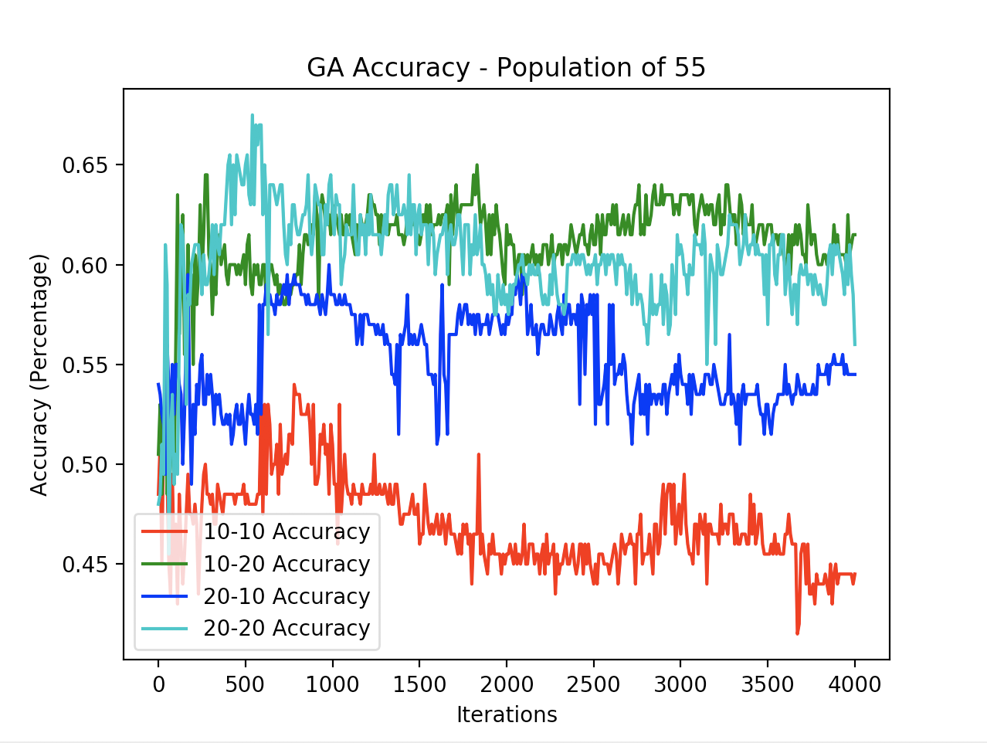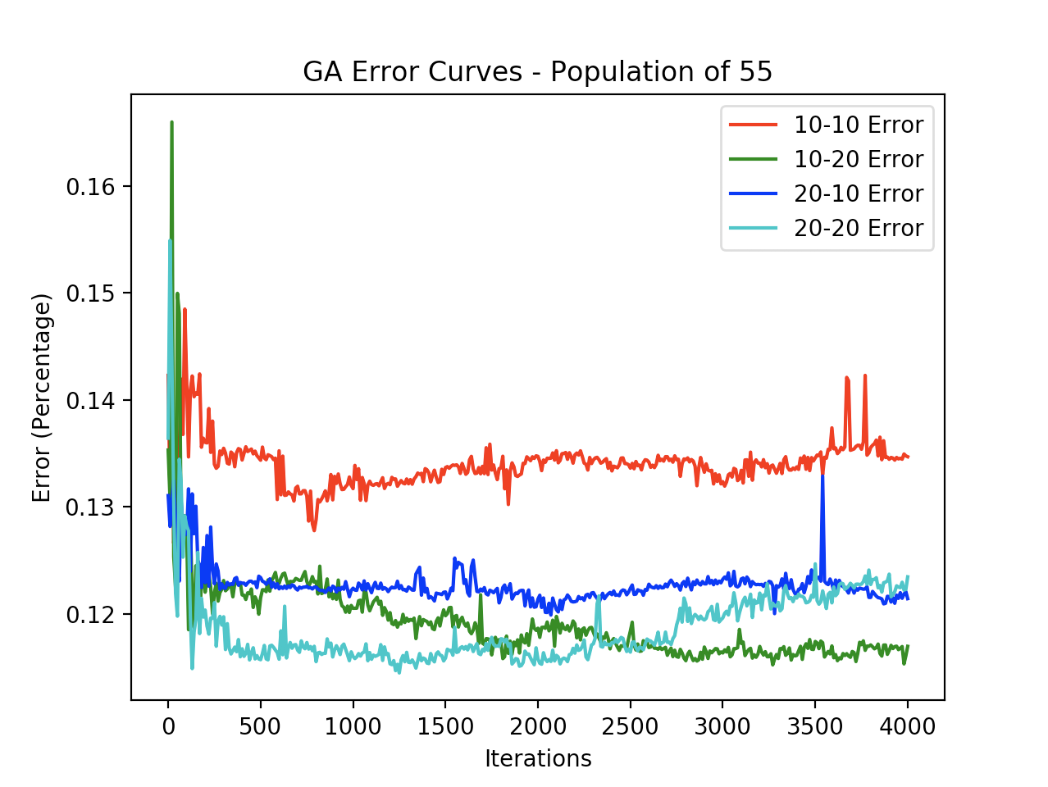

Overall, the genetic algorithm was computationally expensive and not performant. So while it is interesting to investigate, our data suggests, with high certainty, that we would not want to use this search algorithm in further training of a neural network on this dataset. This could be due to the cross over introduced in this algorithm. Since our feature set is not quantitative at all, this could mean that GA does not generalize well over qualitative data. This would be an interesting characteristic to explore for future datasets

**Neural Network Recap**

When looking back over our four search algorithms, we can conclude that GA was by far the most computationally expensive, with BP second most expensive, then RHC and SA depending on the tuning of the parameters of SA. In Figures 7 and 8 we can see how each algorithm performed in accuracy and error, respectively. For each of these lines, we took the “best” tuned parameters that we concluded in each algorithms section above.

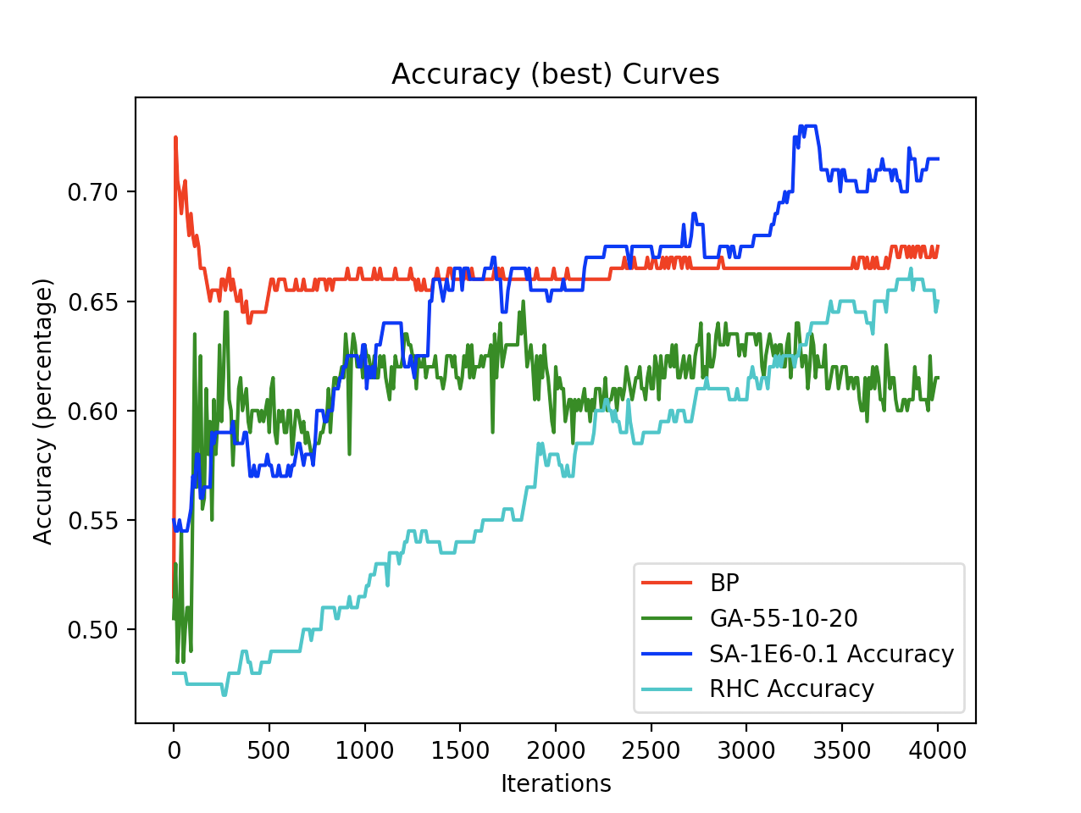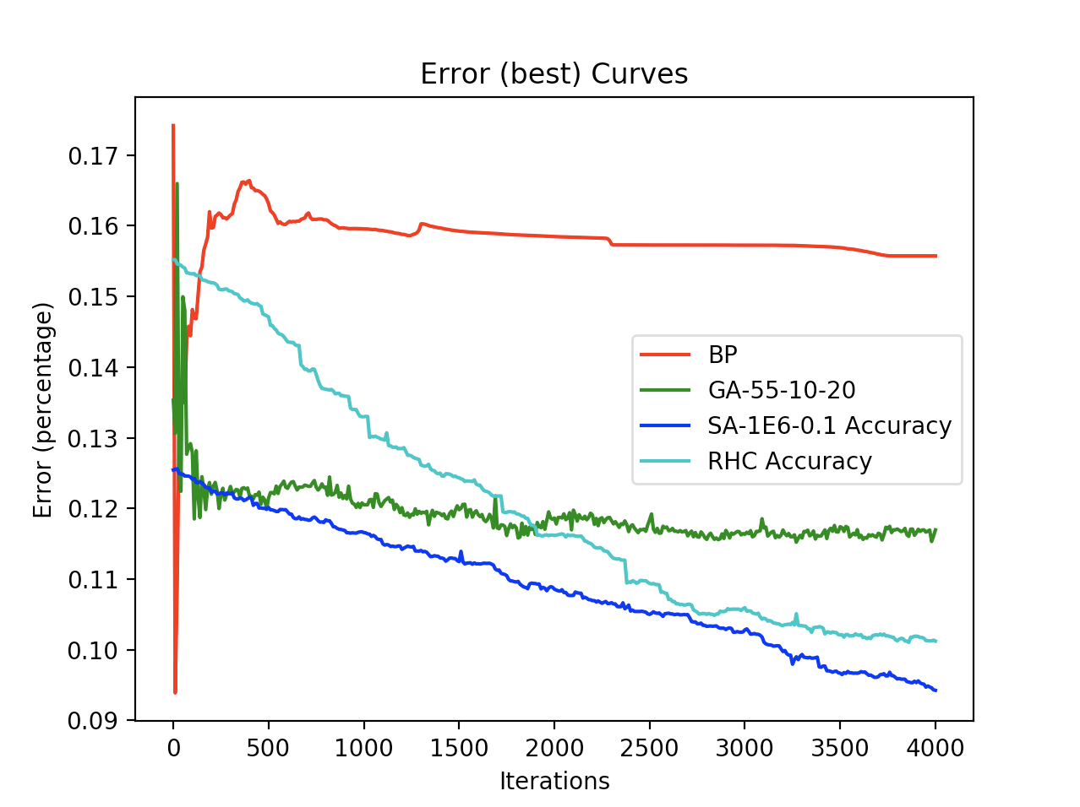

We ran these until 4,000 iterations. This is because in general we saw convergence by this number and GA was computationally slow even at 4,000. It would be worth while to see how the rest of the algorithms converge up to even 6,000 iterations. Maybe we’ll see some increase in accuracy, though I believe this number of iterations correctly distinguishes these four algorithms sufficiently.

From these graphs, we conclude that SA was most performant in terms of overall generalization and resistance to overfitting. It had the closest convergence between it’s training and validation data. The GA accuracy curve seemed to have a lot of noise and converged lower than any of the other algorithms. RHC was still improving in accuracy at 4,000 iterations and so exploring this algorithm further in particular would be interesting to see if it eventually surpasses SA.

With this specific dataset, we are concerned about the curse of dimensionality. So we could see the most optimal gains in our feature selection and transformation. We could certainly do some interesting preprocessing of our data to weed out words that say do not have much of an effect on our algorithm. We could further analyze the relevant vs usefulness of our features use these analytics to enhance our feature selection.

Next steps in further exploring these search algorithms in regard to this dataset would be to take SA and explore other transformations of our dataset that we are feeding the algorithm

**Optimization Problems Overview**

In our optimization problems, we analyze the flip flop, traveling salesman, and continuous peaks algorithms. We apply all four of our searching techniques to these and measure the fitness performance. Fitness is a measure to evaluate the optimum solution of the desired problem at hand. This is the reverse measure of a cost function and allows you to come to the same conclusion. What type of fitness function to use can have a big impact on the performance of your algorithm since it evaluates how well your hypothesis has fit the data.

Here we compare our three optimization problems in respect to MIMIC, SA, GA, and RHC while tuning all the same parameters as before. In order to save space, in the tables below I will only enter the “best” row of each tuning of parameters per algorithm. Assume 4,000 iterations for all parameters. For order of parameters respective of each algorithm, refer to Table 1. MIMIC’s parameters are in the follow order: [population, number of samples to keep, the smoothing constant]. Each algorithm with each set of parameters was run five times. Then the mean of those five outputs was used to calculate the result.

**Flip Flop**

[Flip Flop overview]

|  |  |  |  |
| --- | --- | --- | --- |
| Algorithm | Parameters | Evaluation Value | Time (s) |
| RHC |  | 82 | 8 |
| SA | 1E6, 0.9 | 95 | 12 |
| GA | 55, 10, 10 | 81 | 1.2 |
| MIMIC | 55, 20, 0.3 | 94 | 103 |

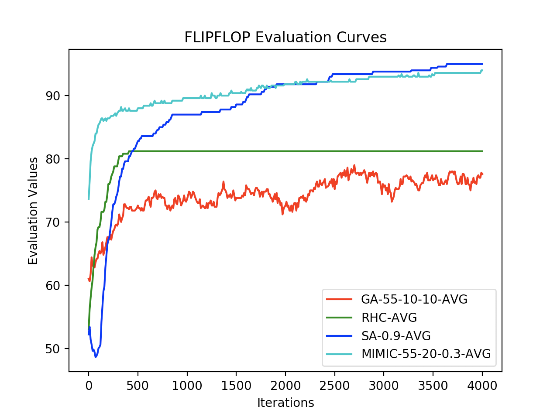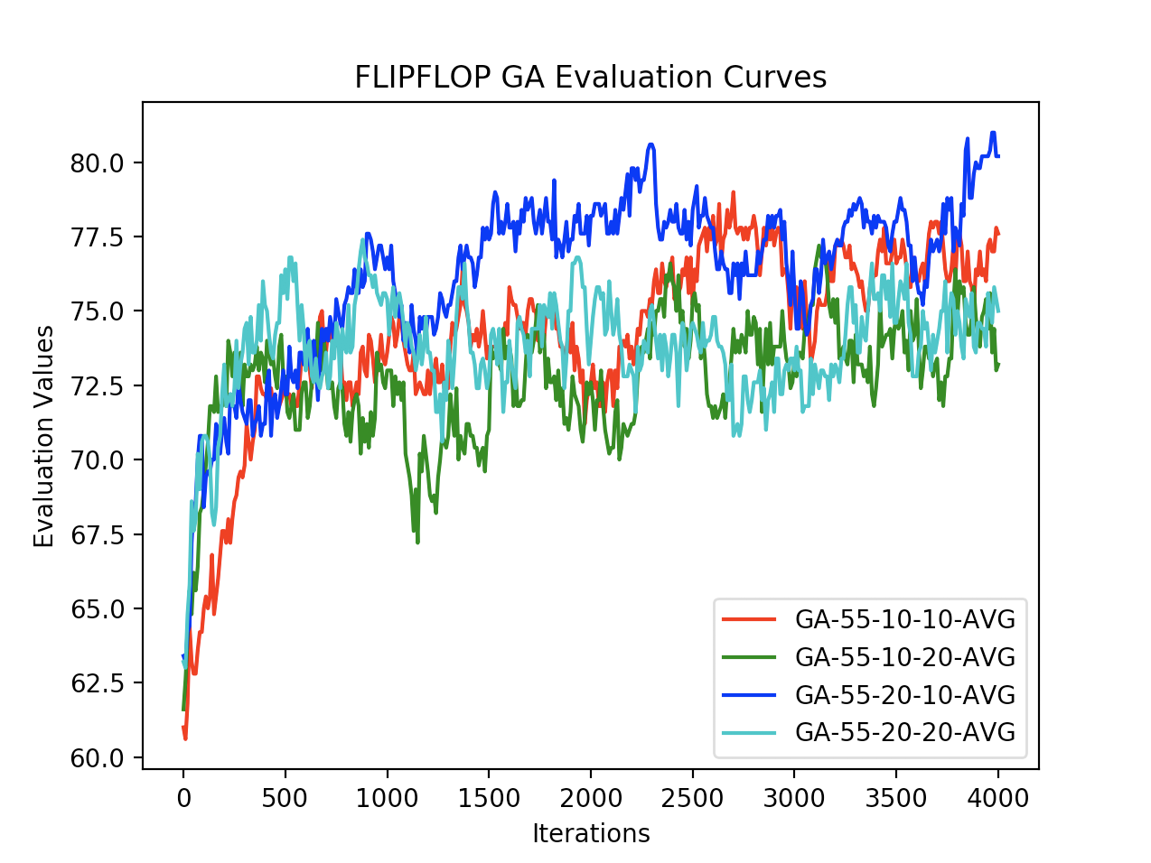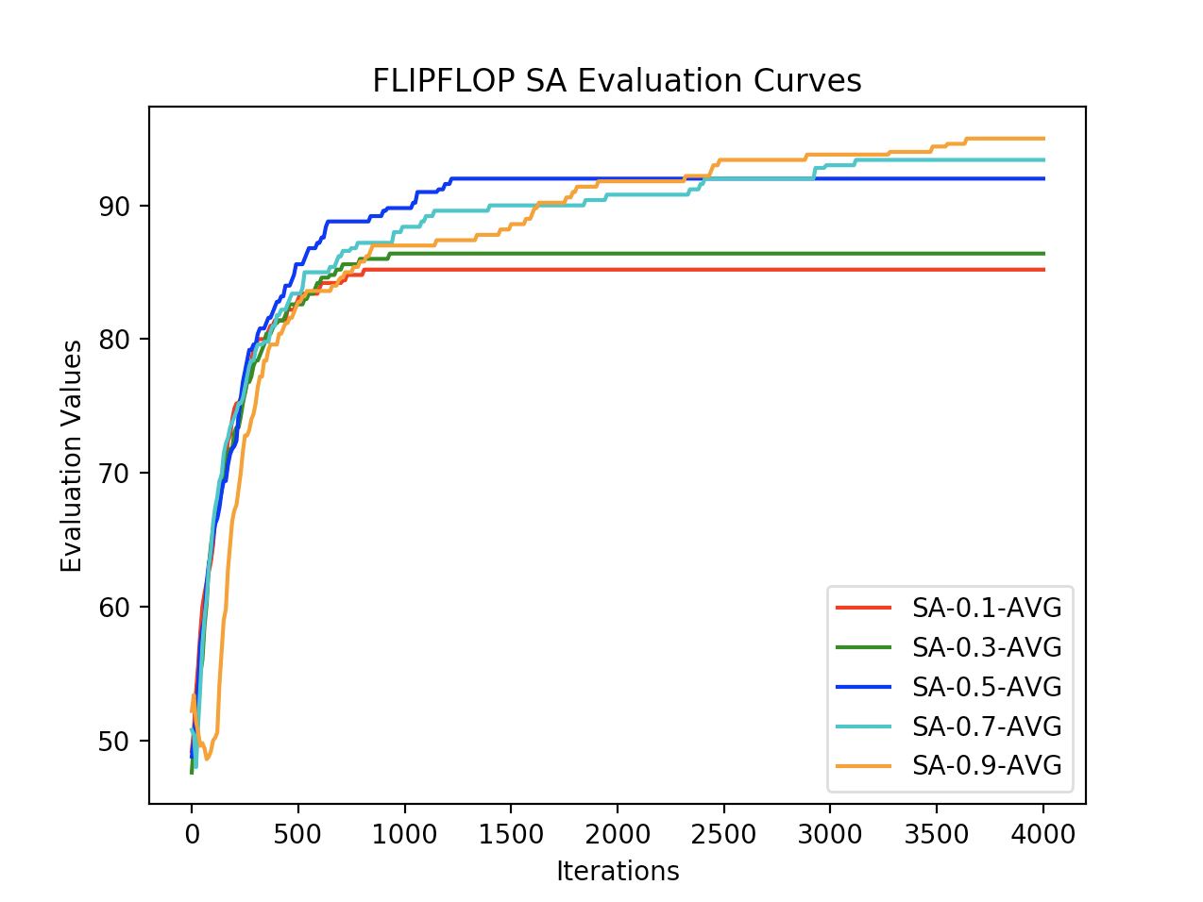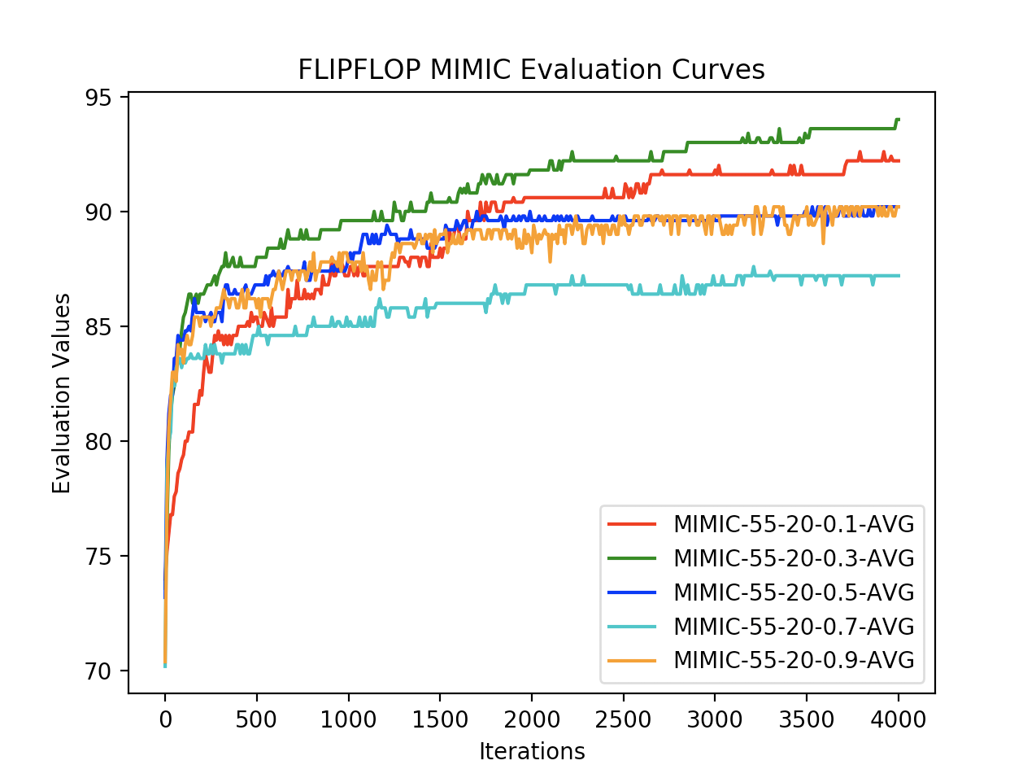

Flip Flop analysis pertaining to this dataset

[Algorithms]

Two extra questions per optimization algorithm

**Traveling Salesman Problem**

[Overview]

|  |  |  |  |
| --- | --- | --- | --- |
| Algorithm | Parameters | Evaluation Value | Time (s) |
| RHC |  | 0.367 | 0.05 |
| SA | 1E6, 0.7 | 0.33 | 0.024 |
| GA | 55, 10, 10 | 0.58 | 60 |
| MIMIC | 55, 20, 0.5 | 1.16 | 151 |

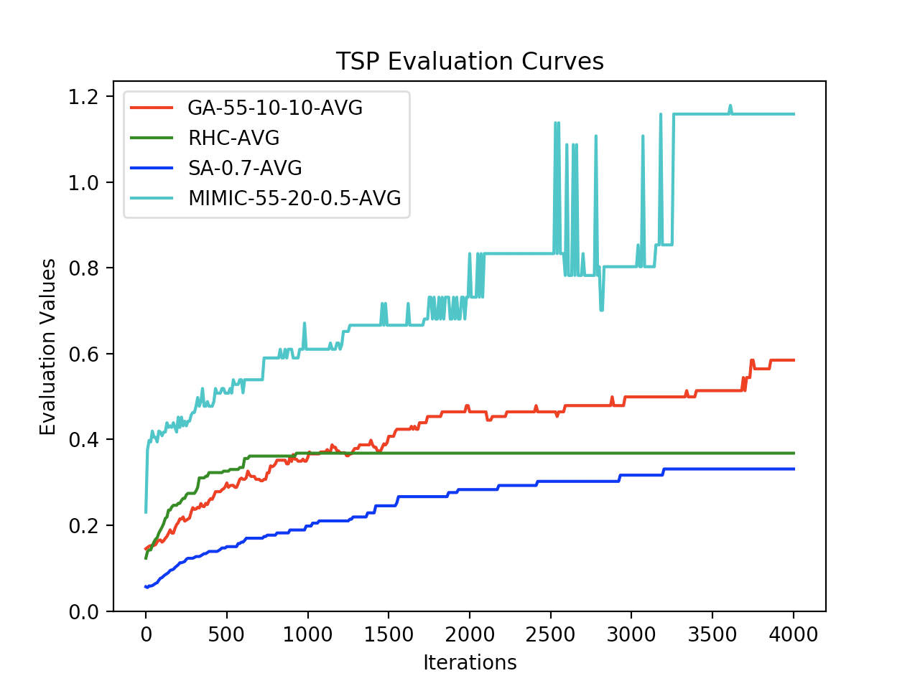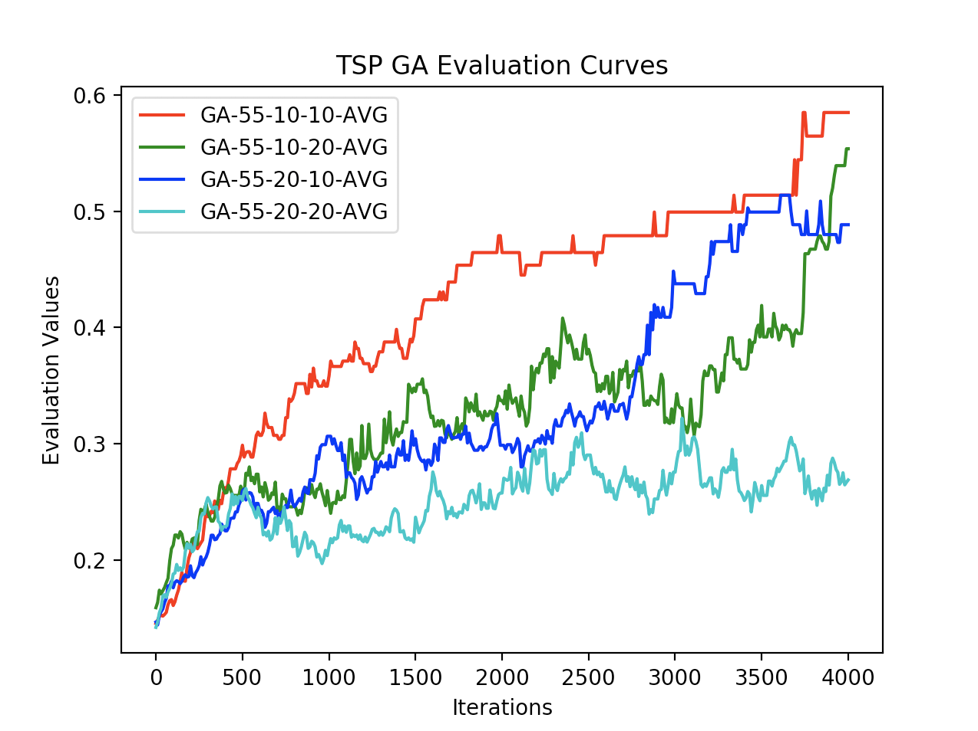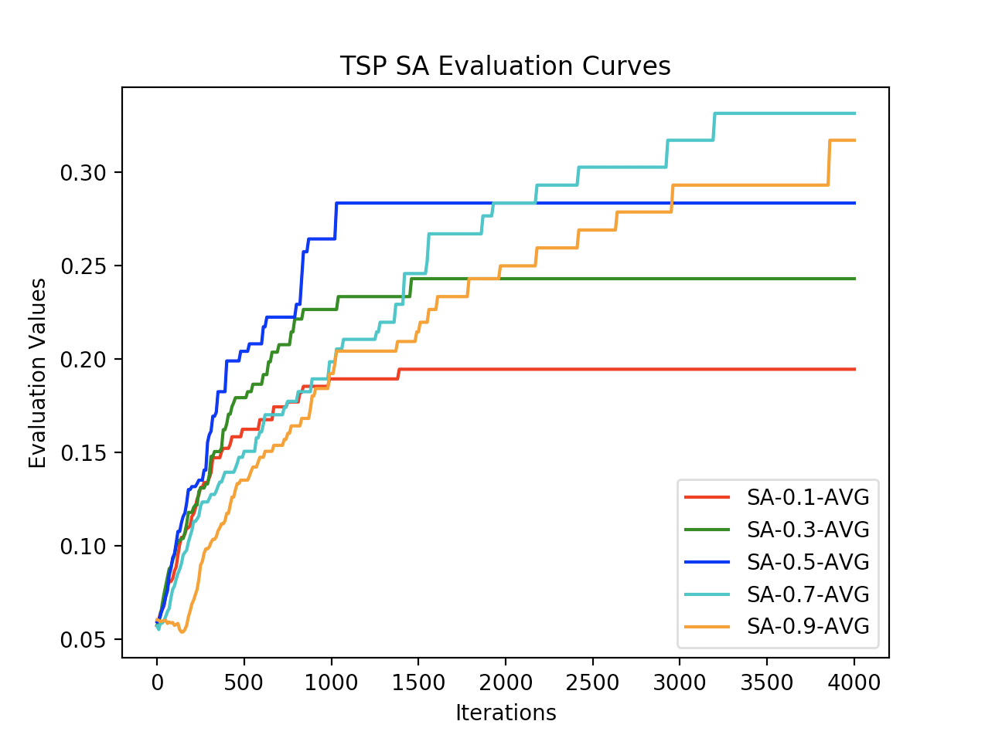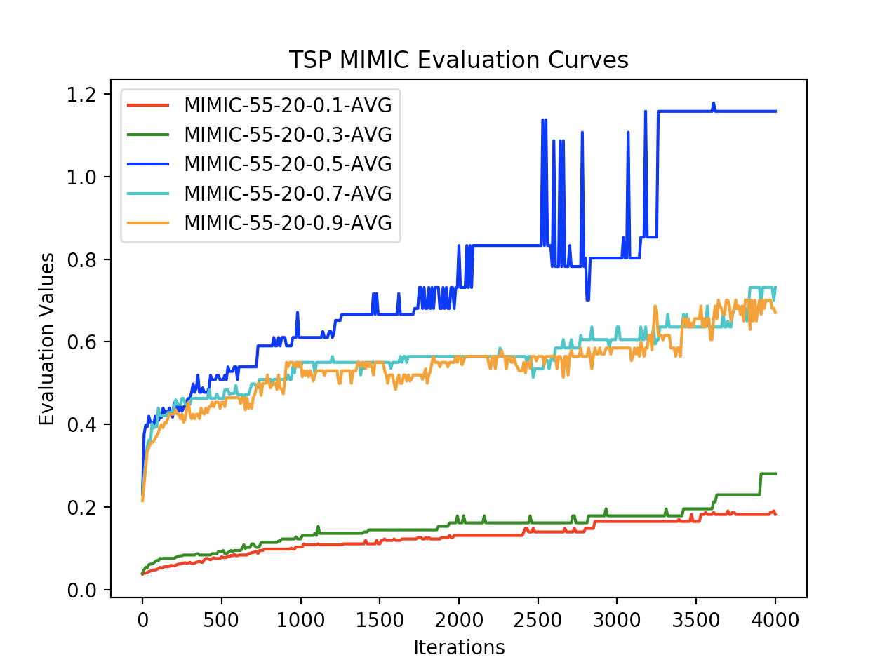

Traveling salesman problem analysis pertaining to dataset

[Algorithms]

Two extra questions

**Continuous Peaks**

|  |  |  |  |
| --- | --- | --- | --- |
| Algorithm | Parameters | Evaluation Value | Time (s) |
| RHC |  | 81.5 | 0.02 |
| SA | 1E6, 0.5 | 95.75 | 0.036 |
| GA | 55, 20, 20 | 65.5 | 1.5 |
| MIMIC | 55, 20, 0.1 | 94.6 | 38.7 |

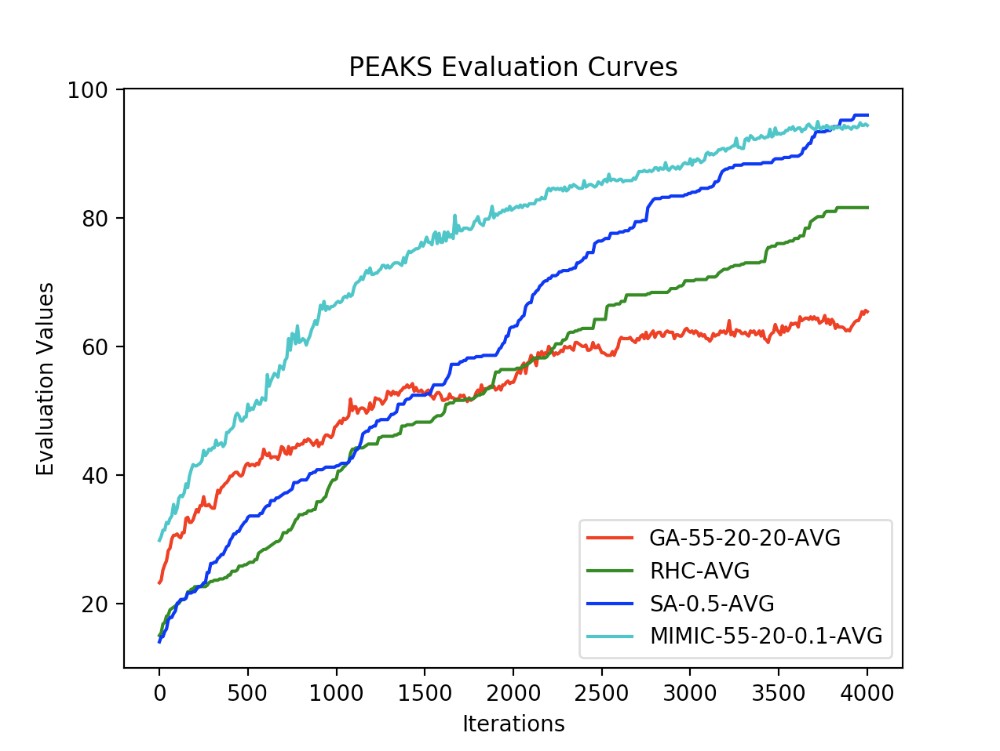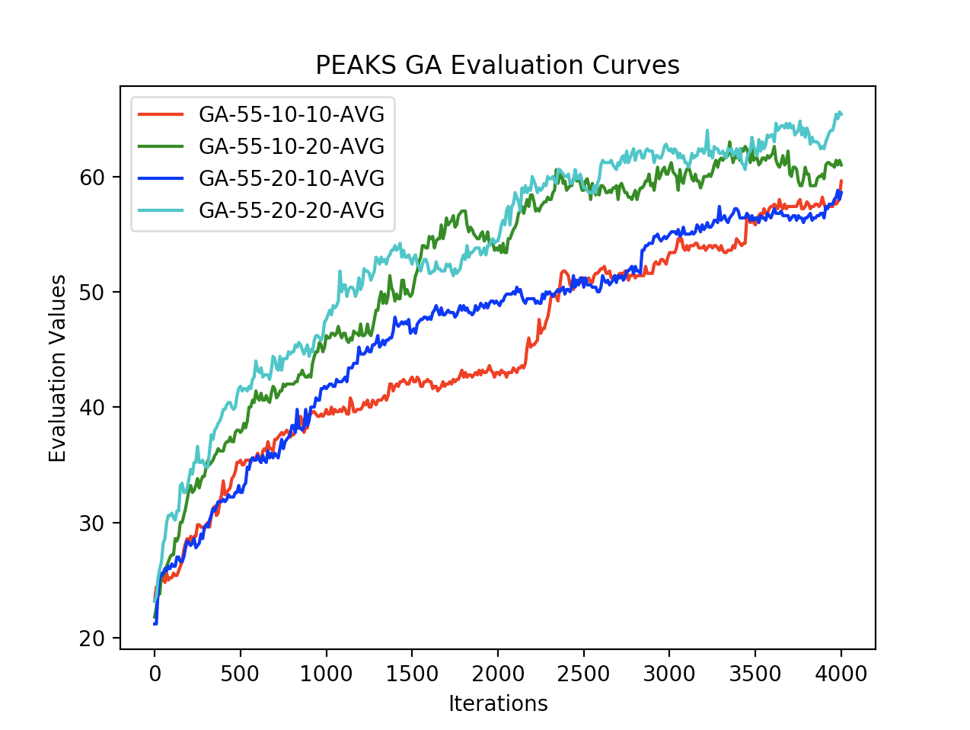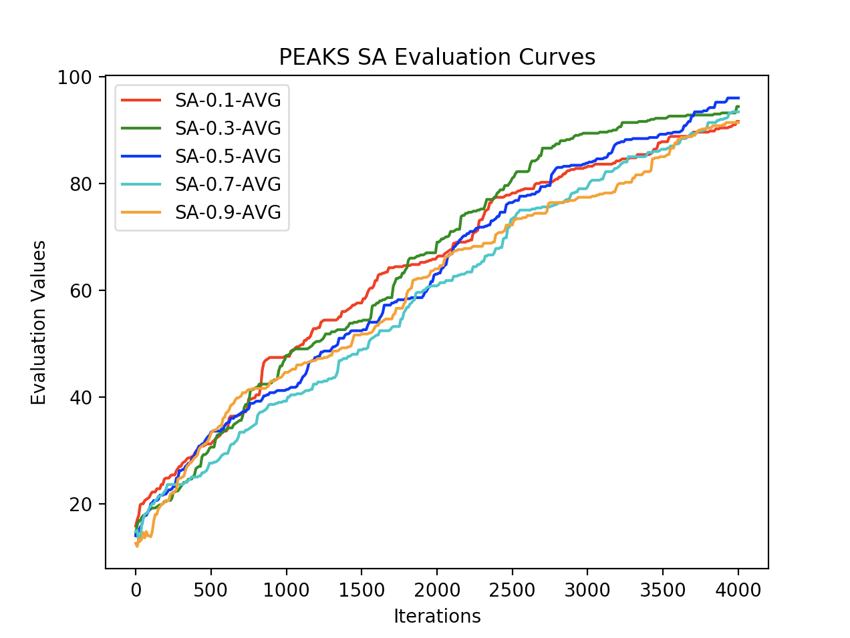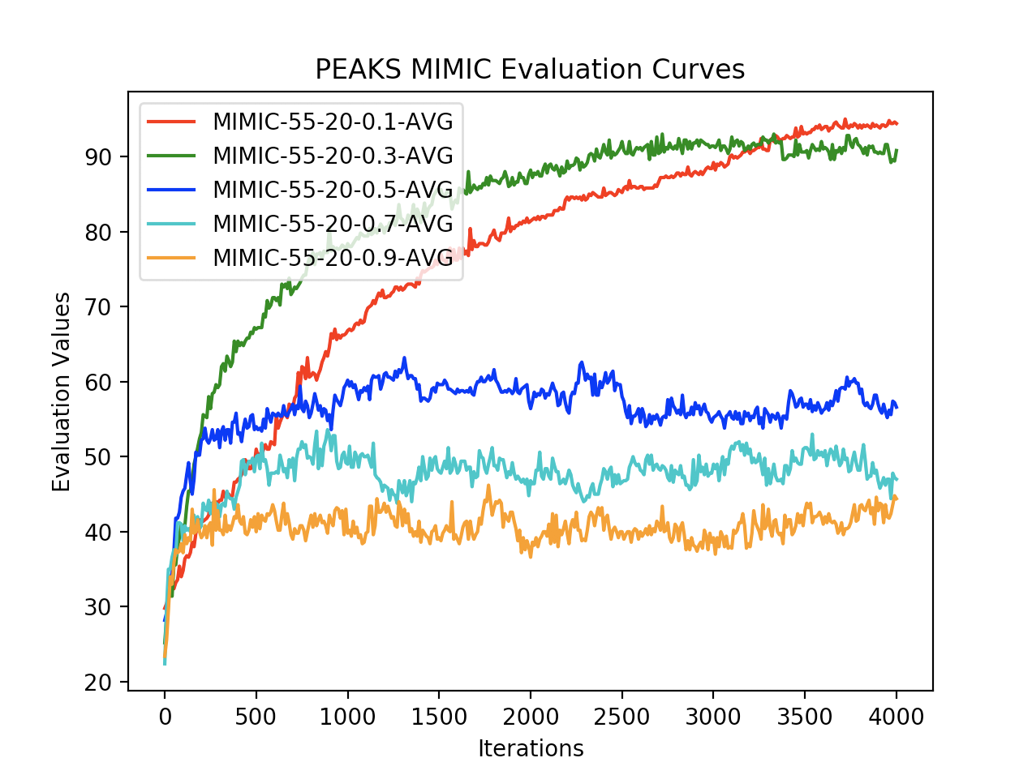

Discuss problem

Table showing optimization’s performance’s

[Analysis]

Graph showing fitness evaluations

What parameters worked best, why?

Answer to 2 questions

[Flip Flop]

Discuss problem

Table showing optimization’s performance’s

[Analysis]

Graph showing fitness evaluations

What parameters worked best, why?

Answer to 2 questions

[Recap Analysis Over All Optimizations]

Which did best, and why (why it was best and how you define best)

Three more questions:

1.

2.

3.

Find a way to compare/contrast different algorithms. How they behave with different search algorithms. Why that is. Which one performed best? And how would you quantify that? What would be an interesting way to explore each of these. Think of three more questions that you may not have the answer to but think would be worth exploring